Game Project Report

Group: Lam Wing Chi , Tsang Chiu Chun , Tsang Yat Hing , Lun Man Chun

Game design: Tsang Chiu Chun

Coding: Lam Wing Chi, Tsang Yat Hing

Animation, sound: Lun Man Chun, Tsang Chiu Chun

We made a 2D adventure game called ‘小男孩的冒險記 – 保衛家園’.We develop this game by using Unity.

How To Play:

As the game start, player can click on start or quit button.

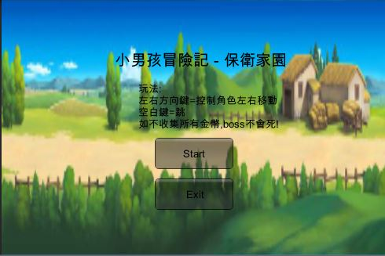

In the main scene, player can press Top, Left, Down, Right to control the main character and ‘Z’ to attack , space bar to jump.

There are a lot of monster in the game . For example:

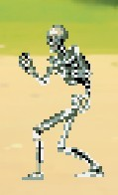

Player need to have good movement skills to avoid the monster and kill them.

Most of the monster have just 2-3 health but they will follow if they detected the main character. When monster die , it will explode and scream(Scream sound record by Lun Man Chun) like below :

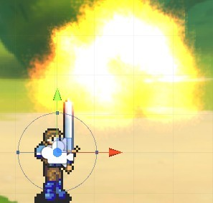

Player need to pay attention to the monster because the main character have only 5 health. While main character collide with the monster, monster will deal damage to the main character like the picture below:

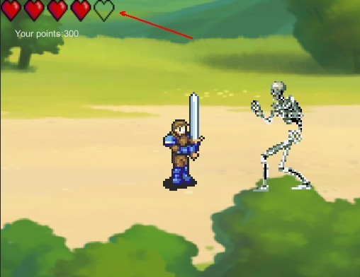

When the heart become zero , the main character will die and the scene will restart.

At the end of level1,there is a boss and player must kill it to get in level2.Here is the boss:

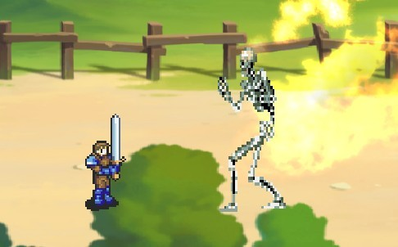

If player want to get in level2, he must collect all the coins before challenging the boss, otherwise the boss won’t die.But the coins are not easy to collect. For example:

Those coins will be place on the jump stage , player need to think how to jump on those jump stage to collect all the coins .(One of the jump stage will fall down suddenly)

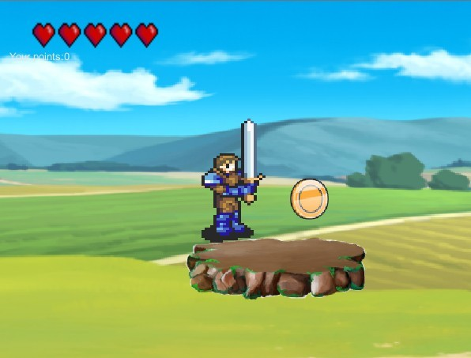

When level2 start, the boss will be generated and starting to chase the main character:

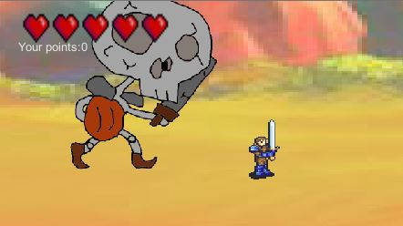

Player need to keep running and kill the coming monster. Player also need to collect all the coins to kill the boss.

Graphics made by Lun Man Chun.

When the boss died, the Win scene will be shown as below:

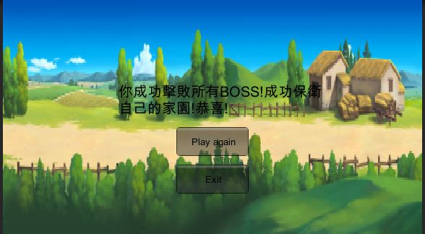

Player can either choose “Play again” or “Exit”.

Online resources:

Main Character :

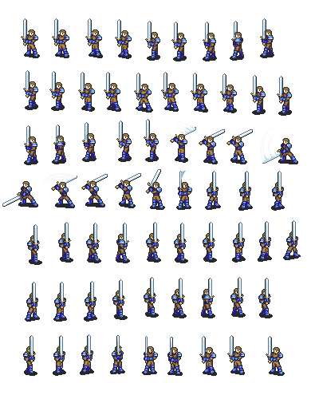

Downloaded from:<http://www.feshrine.net/forums/?showtopic=2654>

Monster Skeleton:

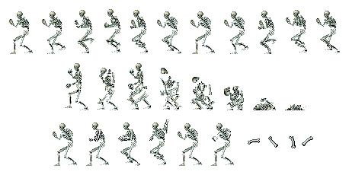

Downloaded from:<http://www.castlevaniacrypt.com/hc/sprites>

Level 1 Background:

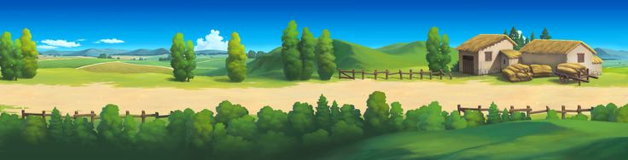

Downloaded from:<http://painterhoya.deviantart.com/art/2D-Game-Background-Resource-442457167>

Level 2 Background: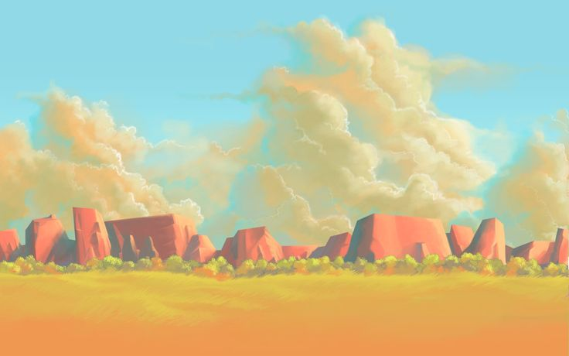

Downloaded from:

<https://www.pinterest.com/pin/366269382173965993/>

Grass platform:

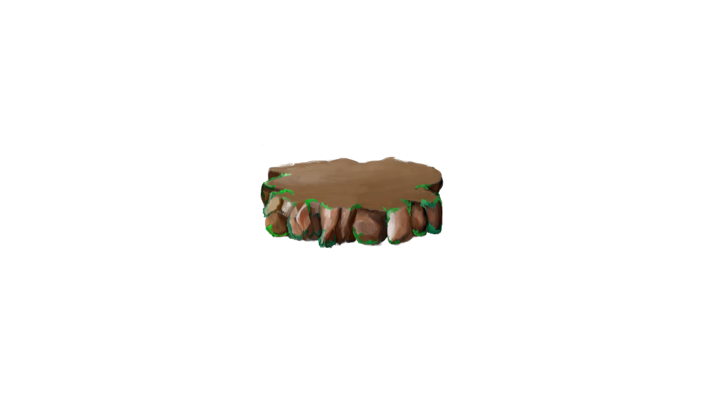

Downloaded from:<https://michaelpezzulo.wordpress.com/2012/04/15/starting-to-build-game-verticle-platform-work-grass-platform-work/>

GUI Heart:



Downloaded from:<https://drive.google.com/file/d/0B0osKu5IdBZgMS1pNEkyNE1fQVU/view> from

<http://guciodevs.com/>

Game BGM:

<https://www.youtube.com/watch?v=K8halcuedf0&list=PLqifyfRtQqVH3ECYbEOlWHG2zslEP-TUv>